**USE CASES**

The section gives information on system features that are identified as use cases relevant to various users of the system.

**1.USE CASE-1: Login**

**Description:**

A login system is provided to the users. Users include the donor, admin, and Recipient.

**Actors:**

Registered donor, admin, and user.

**Flow of events:**

● The system asks the user to enter the username and password.

● User fill in the existing details of username and password.

● The details are validated by the system.

● If they are correct, the user can log in to the system

● If the details are not valid, an error user message is displayed by the system.

**Post-Condition:**

The home/main page of the system is displayed after successful login.

**2.USE CASE-2: Logout**

**Description:**

The user should be able to log out of the system. Users include the donor, admin, and Recipient.

**Actors:**

Registered donor, admin, and user.

**Flow of events:**

● The system asks the user to enter the username and password.

● User fill in the existing details of username and password.

● The details are validated by the system.

● If they are correct, the user can log in to the system

● If the details are not valid, an error user message is displayed by the system.

**3.USE CASE-3: Donor Profile**

**Description:**

The user will be able to see their Account Number, Blood Donation Receipts, Donation to the Bank, Blood Need to the Bank, and Blood Request.

**Actors:**

Registered donor, admin.

**Flow of events:**

● User selects the user details option

● System displays the user details

● User selects the update user details option

● System displays the existing user details

**4.USE CASE-4: Blood Stock Management**

**Description:**

If the donor is registered with the bank, it will display the Complete Donor Information or Account No. along with the Blood Details for that particular bottle.

**Actors:**

admin, user.

**Flow of events:**

● The user chooses the blood group stock he wants

● System checks for the blood group from bloodstock

● System presents the amount of blood present in stock

● System presents the donor's details of the specific blood group

● Else, it displays no details are present.

**USE CASE DIAGRAMS**

**SCENERIO 1**

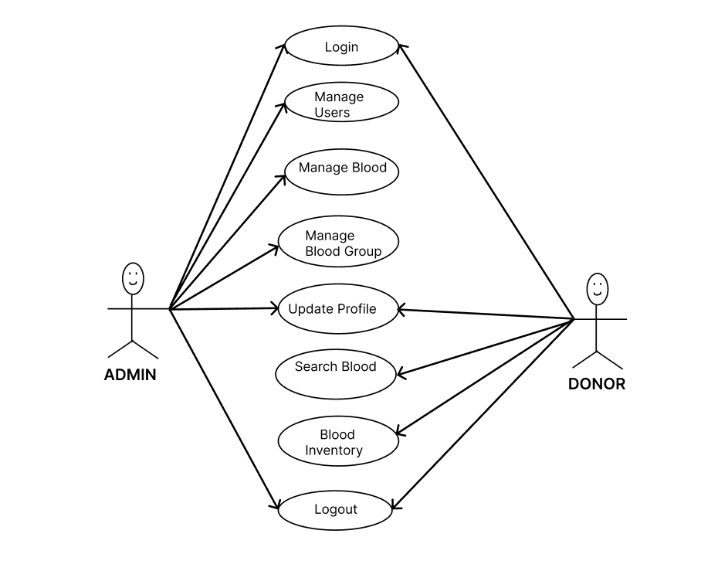

**SCENERIO 2**

